PlayAbility Toys APH Product Descriptions
Paint Pot Palette
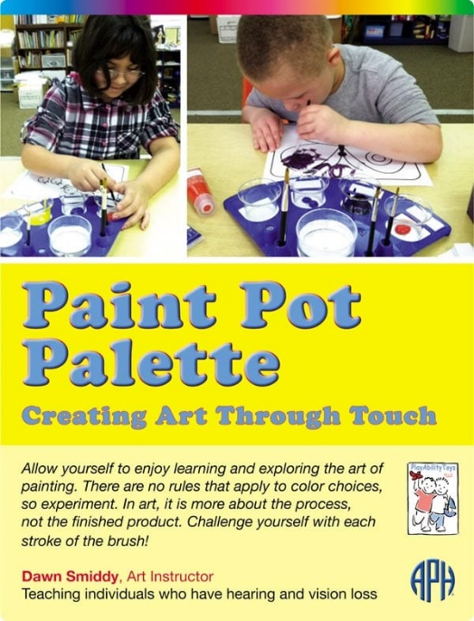
The Paint Pot Palette includes a set of custom-made, whimsical drawings — by San Francisco artist Debi Harrison — titled Color SENSEation. The pictures are printed and embossed on heavy paper; each picture is titled in print and braille. The embossed lines make it easy to trace the subjects with the fingers and then follow with a crayon or paint brush — this makes it easier for beginning artists to learn to color and paint.

Paint Pot Palette, when used with Color SENSEation:
- Teaches color concepts
- Encourages visual and tactile exploration
- Teaches shape recognition
- Provides braille practice
- Develops fine motor skills
- Promotes individual expression
- Encourages social engagement
Paint Pot Palette kit includes:
- Palette
- 4 Paint pots
- 4 Brushes (two round and two flat)
- Water cup
- 9 braille tiles (one is blank)
- Watercolor paint (1 tube each of red, blue, yellow, black, and white)
- Coloring pages (Color SENSEation)
- Stir stick

Paint by Number Safari Book Series
Tropical Rainforest
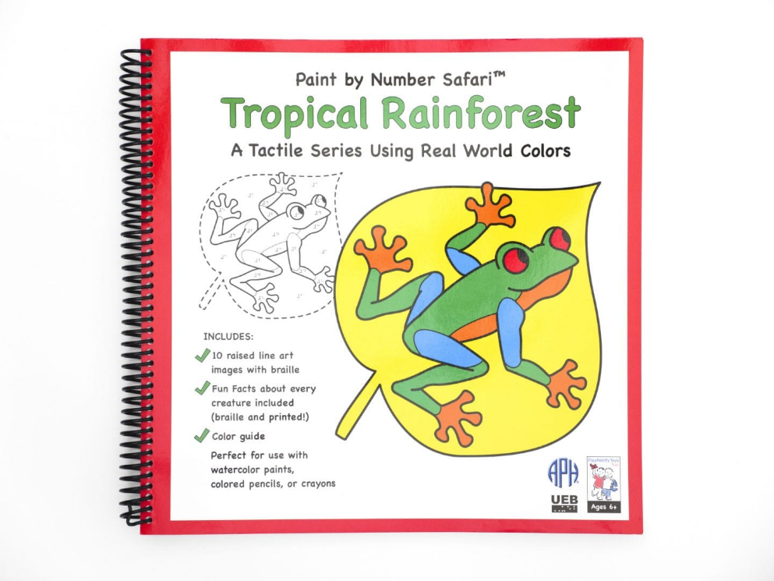
Tropical Rainforest is the first of the Paint by Number ™ Safari Series. Paint by Number Safari includes a set of custom-made drawings of real-world subjects that are printed and embossed on heavy paper.
The embossed lines make it easy to trace the subjects with your fingers and then follow with a crayon, colored pencil, or paintbrush; this makes it easier for beginning and intermediate artists to learn and improve their skills. The wide, solid, embossed lines identify the animal, and the thin embossed lines depict color separation on the animal’s body. The dashed lines identify background images such as leaves, branches, and flowers. Solid raised areas identify parts of the images that are too small to fill with color, such as small bugs and small body parts.
Includes:
- 10 raised-line art images with braille
- Fun facts about every subject, print and braille
- Color code
- Color concepts with an emphasis on real-world colors
- Encourages visual and tactile exploration
- Teaches shape recognition
- Develops fine motor skills
- Encourages social engagement
- Teaches fun facts about amazing creatures including:
  - Snake
  - Capybara
  - Hummingbird
  - Frilled Lizard
  - Butterfly
  - Uakari
  - Toucan
  - Sloth
  - Tree Frog
  - Chameleon

Backyard Creatures
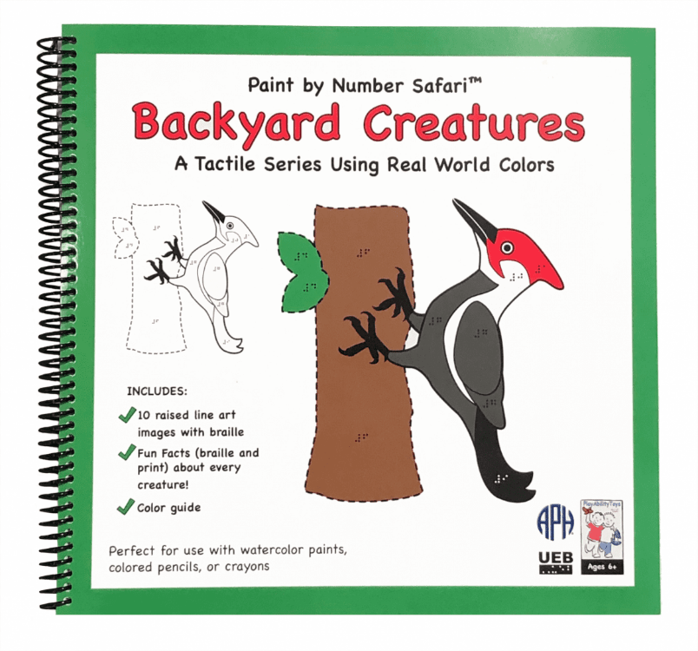
Great for beginning and intermediate artists, Backyard Creatures is the third addition to APH’s Paint-by-Number Safari ™ Series. Students will enjoy perfecting their art skills as they learn about the colors and creatures found right outside their door. Custom-made drawings of life-like wildlife are printed and embossed on heavy paper, making this coloring series fun for all!
Wide, solid, embossed lines identify the creature, while thin embossed lines denote color separation on the creatures’ body. Dashed lines identify background images, and solid, raised areas identify parts of the images that are too small to fill with color. Each image includes fun facts about that creature’s life, including size, diet, predators, and environment, along with specific color code for that creature.
Includes:
- 10 raised-line art images with braille
- Fun facts about every subject, print and braille
- Color code
- Color concepts with an emphasis on real-world colors
- Encourages visual and tactile exploration
- Teaches shape recognition
- Develops fine motor skills
- Encourages social engagement
- Teaches fun facts about amazing creatures including:
  - Wild Turkey
  - Woodpecker
  - Bats
  - Racoon
  - Striped Skunk
  - Luna Caterpillar and Moth
  - Ladybugs
  - Rabbit
  - Deer
  - Red Squirrel

Under the Sea
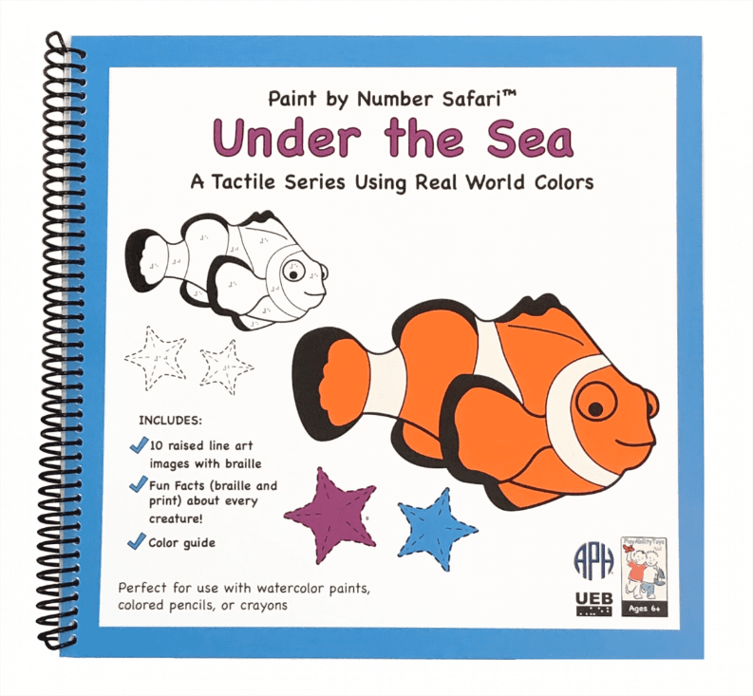
Under the Sea is the next addition to APH’s Paint by Number Safari™ Series. Students will enjoy perfecting their art skills as they learn about the colors and creatures found under the sea. Custom-made drawings of life-like sea creatures are printed and embossed on heavy paper, making this coloring series fun for beginning and intermediate artists!
Wide, solid, embossed lines identify the sea creature, while thin embossed lines denote color separation on the creatures’ body. Dashed lines identify background images, and solid, raised areas identify parts of the images that are too small to fill with color. Each image includes fun facts about that creature’s life, including size, diet, predators, and environment, along with specific color code for that creature.
Includes:
- 10 raised-line art images with braille
- Fun facts about every subject, print and braille
- Color code
- Color concepts with an emphasis on real-world colors
- Encourages visual and tactile exploration
- Teaches shape recognition
- Develops fine motor skills
- Encourages social engagement
- Teaches fun facts about amazing creatures including:
  - Seal
  - Clown
  - Sea Horse
  - Sea Turtle
  - Stingray
  - Octopus
  - Jellyfish
  - Lobster
  - Shark
  - Dolphin

Desert Creatures
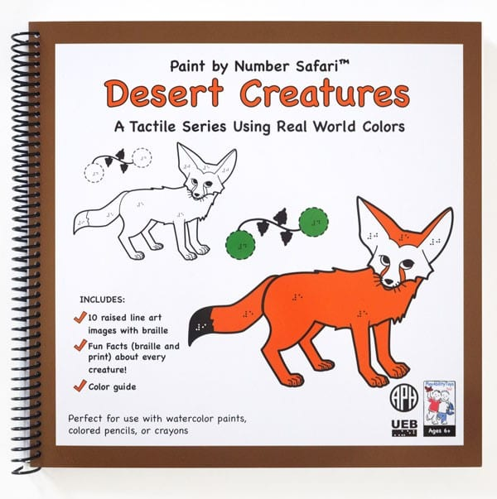
Desert Creatures is the fourth addition to the Paint-by-Number Safari™ series, which is designed specifically for beginning and intermediate artists. Students will enjoy perfecting their art skills as they learn about the colors and creatures found in the desert. Custom-made drawings of life-like desert creatures are printed and embossed on heavy paper, making this coloring series fun for all.
Wide, solid, embossed lines identify the creature while thin embossed lines denote color separation on the creature’s body. Dashed lines identify background images and solid, raised areas identify parts of the images that are too small to fill with color. Each image includes fun facts about that creature’s life, including size, diet, predators, and environment, along with specific color code for that creature.
Includes:
- 10 raised-line art images with braille
- Fun facts about every subject, print and braille
- Color code
- Color concepts with an emphasis on real-world colors
- Encourages visual and tactile exploration
- Teaches shape recognition
- Develops fine motor skills
- Encourages social engagement
- Teaches fun facts about amazing creatures including:
- Desert Big Horn Sheep
- Arabian Camel
- Desert Tortoise
- Fennec Fox
- Gila Monster
- Desert Lion
- King Penguin
- Roadrunner
- Tarantula Hawk Wasp
- Verdin

Rib-It-Ball: Jacob’s, 14, 18, & 30 Inch
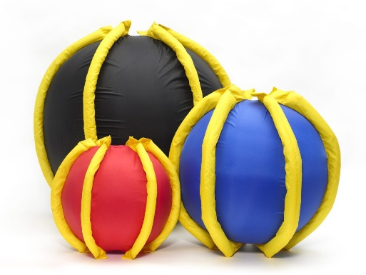
These fun balls are easy to grab and have high contrast ribbing. Crinkly fabric in the ribs adds a tactile and auditory component.
Jacob’s Rib-It-Balls are latex-free inflatable balls that have been designed in two-color combinations, making them easier for visual coordination. They are available in three sizes: 14 inch (red/yellow), 18 inch (blue/yellow), and 30 inch (black/yellow). The 30-inch ball is sold with a foot pump.

