# Monarch Version 1.2 Frequently Asked Questions

## KeyMail:

### Q: I am a Gmail user, can I use this with the KeyMail email application on the Monarch?

A: Yes, KeyMail supports Google authentication, however at this time does not support the synchronization of Google contacts. All emails will synchronize among your Gmail enabled devices. When creating your account for the first time, select to “Add Authentication,” from the available settings screen and you will be prompted to sign in with Google.

### Q: My organization or school uses Microsoft 365. Does KeyMail support these types of accounts?

A: Yes, KeyMail supports Microsoft 365 authentication with email and contacts synchronization across your devices. When creating your account for the first time, select to “Add Authentication,” from the available settings screen and you will be prompted to sign in with Microsoft. You may be prompted after a successful sign in, to enable an admin mode which will allow your Monarch to connect to the server.

### Q: I am trying to add a Microsoft365 or exchange account and am getting this message. “Need admin approval.  Technologies HumanWare Inc needs permission to access resources.” What do I need to do?

A: In the IT Administrator’s dashboard the network administrator should be able to grant a user the ability to request for an app to allow for access to the Exchange email server. The administrator will find a text box where they can label what app they are granting permission. An example might be KeyMail for the Monarch. Upon granting permission the Monarch user can relog in and ask that this app be allowed to be granted access to receiving and sending Email. Once the Admin grants access anyone with a Monarch will have access going forward on that network when they log in on their units with their accounts. Below you will see a screen shot of the Network Administrator’s dashboard where these changes can be made.

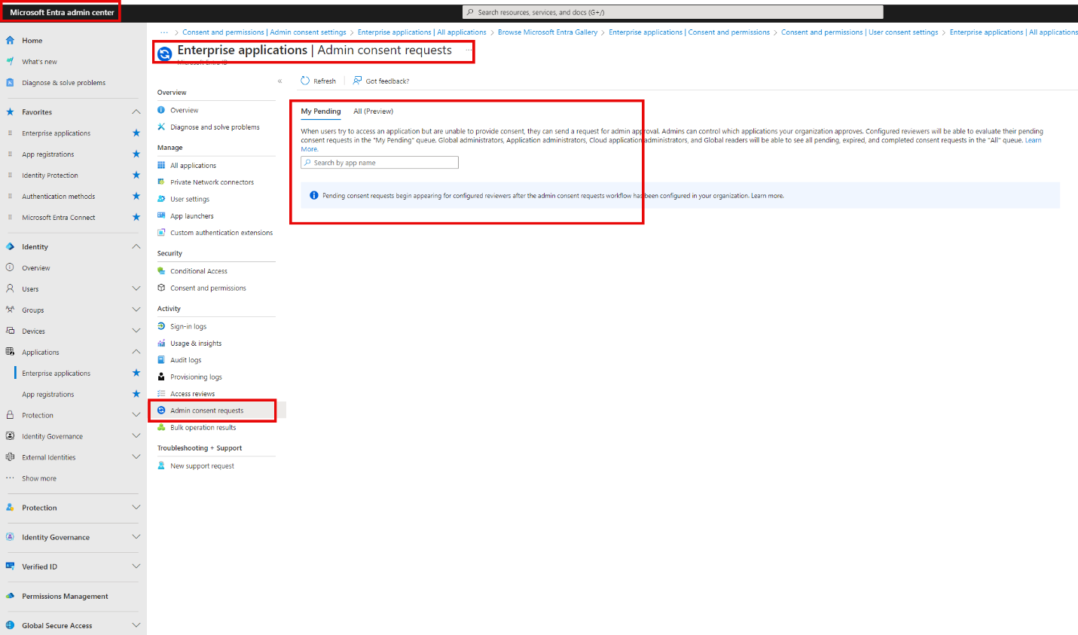

### Q: Does KeyMail have a spell check feature?

A: Yes. All functions and shortcuts can be found in the Monarch’s context menu by pressing space with M or holding the square button on the front of the device. The shortcut for spell check is space with dots 1-6.

### Q: How do I type the ‘@’(at) sign when writing an email address?

A: If using UEB braille the ‘@’ sign can be inserted by pressing dot 4, followed by dot 1. If not using UEB, you will be prompted “Computer braille is required” to which you will need to enter the symbol using computer braille. Please refer to the computer braille symbol list in the Monarch user guide.

## Web Browser (Ecosia)

### Q: When I first received my Monarch the web browser only allowed me to login to my network and it was really slow. What is different now?

A: In the previous version of the Monarch software we had a Beta version of the web browser. We knew it was necessary to ensure users could connect to web portal WIFI networks, such as those in schools or hotels. However there were several limitations.  
  
With version 1.2 of the Monarch software the Beta status has been removed and the web browser is robust. Students can complete research projects using the Monarch browser, access audio or video content, sign into learning management systems, and much more. Files can be downloaded to the Monarch directly via the web browser and most importantly users can see up to ten lines of braille from a web page at a time.

### Q: Can I use point and click to activate a link on a web page?

A: Yes. Point and click is one of the fastest methods to identify and click on a link or object on a web page.

### Q: Most web browsers have a toolbar or navigation menu above the web content that allows you to navigate forward, back, type in a web address, etc. Where is this on the Monarch?

A: Similar to most other locations within the Monarch, all functions that one would find on a web toolbar can be found in the familiar context menu, accessible by pressing space with M, or by holding the square button on the front of the device. All web functions have associated keyboard shortcuts for efficiency.

### Q: Are you able to toggle between web content and tabs list?

A: Yes, pressing **Backspace with T** will toggle between the web content and tabs list.

### Q: My webpages are not loading correctly, how do I troubleshoot this?

A: If something isn’t loading correctly in the web browser, the first thing you should try is removing the web browser from your recent apps list. To do this, simply tap the square button on the front of the device, navigate to the Ecosia app and close it by pressing the shortcut Backspace with dots 2-3-5-6. Then reopen the web browser. This simple troubleshooting step can fix several app issues if they do arise.

## Victor Reader

### Q: I downloaded the Treasure Island eBraille preview, now how do I open it in the Victor Reader app?

A: After downloading the Treasure Island eBraille preview file, open the Victor Reader app from the main menu. Choose to “Import Book.” This will open a file browser window. Press space with D to navigate back to the drive selection screen where you can choose your internal storage. From within the internal storage, the default folder the web browser downloads to is the “Downloads,” folder. Select that and you will see your Treasure Island.ebrl file. Upon activating that file you will see that the import is complete. Press enter on the OK button to be returned to the Victor Reader menu. Open the “My Books,” item and you will find the Treasure Island eBraille book. Press enter to open it.

### Q: Why don’t I hear my text to speech voice reading after I load an eBraille book?

A: eBraille is made up of Unicode braille characters, enabling it to represent true braille formatting, however currently cannot be translated to be read by a text to speech voice. This could be an enhancement for the eBraille standard in the future. But similar to reading braille on paper, eBraille strives to offer that same efficient experience.

### Q: I was told that eBraille would show spatial braille formatting, just like I would see on paper. In version 1.2 of the Monarch software I’m not seeing any spatial formatting.

A: Version 1.2 of the software includes a preview for the eBraille experience. This is done to provide users, who haven’t heard of the new eBraille standard, the opportunity to read a true eBraille file. We have selected the book “Treasure Island,” which contains an included tactile graphic of the treasure map found in the book. You can point and click on the graphic to open it in the Tactile Viewer app. This preview version includes two of the three pillars of eBraille

* Quick navigation by table of contents and heading level
* Instant access to included tactile graphics.
* We are working with our partners to complete support of the third pillar, Spatial Braille Formatting, and we expect to have this finished in a few months.

### Q: I am trying to find a keyword in the Treasure Island eBraille book using the find command, but it fails to find some of the words I try searching for.

A: When searching for a keyword in an eBraille document, you must enter it exactly as it appears in the text. If the document is fully contracted, be sure to type the keyword in its contracted form; otherwise, the search will not find it.

### Q: After opening the Tactile Graphic from the Treasure Island eBraille book, how do I go back to the text?

A: If you press the back button (Triangle key) on the front edge of the Monarch, you will return to the book. To switch between the document and the graphic for reference, press the app switcher button (Square key on the front edge). This allows you to toggle between the open graphic and the text.

### Q: How do I insert Bookmarks?

A: Version 1.2 introduced the capabilities of Bookmarks in Victor Reader. To insert a bookmark, press **Enter with M**. You will be prompted with “Insert Bookmark followed by a number”. Press enter to accept the bookmark number or type a new number. (Make sure to type in the number sign first).

### Q: How are bookmarks identified when reading on the braille display?

A: When a bookmark is inserted, it will add a format marker. The format maker of a bookmark is identified as dots 1-2-4-6, followed by b, followed by k.

### Q: How can I import and export my bookmarks to share with other Monarch users?

A: When you create a bookmark in one of your books, a file is generated that compiles your bookmark list. This file is located in the following folder:

**Android\data\com.humanware.victorreader2\files\BookmarkData\bookmarks.csv**

1. Using KeyFiles, you can copy and paste this file anywhere you like, such as onto external storage, if you want to share it with another Monarch user.
2. To import the file in the Victor Reader app:
3. Open **Settings** and select **Import Bookmarks**.
4. The **KeyFiles** window will appear.
5. Press **Space + D** to access your list of drives.
6. Navigate through folders, subfolders, or files to locate your bookmarks file.
7. Press **Enter** to import it.
8. A dialog box will confirm whether the import was successful and display the number of bookmarks imported.

## Miscellaneous:

### Q: Why do my Gmail contacts not sync with the contacts app on the Monarch?

A: Google requires a specific certification to synchronize contacts and this is a pending approval, we will complete in the future. You can quickly add a contact directly from an email using the context menu to ensure your frequent contacts are logged.

### Q: I am a teacher of the visually impaired and use a monitor with my student so I can see what they’re working on with the Monarch. Is it possible to quickly toggle on the visual braille mode without going through all the Options sub-menus?

A: Yes, with version 1.2 we introduced a quick toggle of the visual braille mode with the shortcut of backspace plus enter plus V.

### Q: How do I update to version 1.2?

A: There are a few ways of updating to the latest version 1.2 firmware.

1. **If you have Monarch connected online, then you can use over the air update.** 
   1. Select the all application menu item.
   2. Select KeyUpdater
   3. Select Check for updates
   4. If an update is found, you will be asked if you wish to install or cancel.
2. **Offline update**

In the event you are unable to update over the air, and an offline update is available.

* 1. Download the update files from the HumanWare or APH support page.
  2. Place the update files on the root of the USB thumb drive.
  3. Insert the thumb drive into Monarch
  4. From the Main Menu, press **A** to jump to All applications.
  5. Then press Enter to select “All Applications.”
  6. Press the letter “**K”** until you are prompted with “KeyUpdater”.
  7. Press **Enter** to select “KeyUpdater”
  8. Press Enter to select “Application update.”