Jupiter Skills Checklist
Mastery level can be marked as I (introduced), P (progressing), M (mastered), or as the instructor sees fit.

NOTE: The skills listed here are specific to the Jupiter video magnifier. Basic CCTV skills are not included on this list.

Device Setup and Orientation
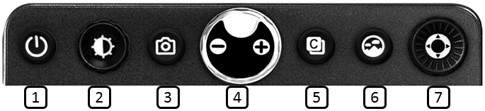
Skill | Action/Gesture | Mastery Level | Date
Opening Jupiter | Unfold the stand and position the LCD screen in a suitable position. Using one hand hold the Jupiter flat on the table and use the other hand to pull open the stand. Pull the LCD screen towards you and lift it up until the screen is at the correct height for eye level.
① Power On/Off button | Press the button for 2 seconds.
② Image optimizer wheel | Turn the knob to adjust the screen brightness.
③ Snap shot button | Briefly press the button and the image on the screen will freeze.  ㆍ You can then zoom in/out on the still image and adjust color and screen brightness.  ㆍ Press the button again, to return to live magnifier mode.  ㆍ Use the Super Function Key to scroll the frozen image.
④ Zoom Wheel | To adjust the magnification, turn the knob.  ㆍ Magnification ratio:  Live image mode: 1.8 x ~ 30 x  Snap shot mode: ~ 150 x  Adjustable magnification: 1.2 x ~ 250 x  Press and hold the button to use the menu mode.
⑤ Color mode button | Press the button to cycle through 8 color modes. Up to 35 color modes can be set using the menus.
⑥ Natural color button | Press the button to view pictures or documents in natural color.  Press and hold the button to use the ‘Find function’.
⑦ Super Function Key | Scrolling the frozen image.  Selecting and using the line/mask functions.
Lines & Masks Toggle | Press and hold the Super Function Key to activate Line & Mask.  Toggle the button Left & Right ◀▶ to choose the function.  Toggle the button Up & Down ▲▼ to Increase or decrease the thickness of a line and the distance between masks.  Turn the knob to move the position of the Line & Masks.
Auto Focus on/off | Turn on/off the focus lock by pressing and holding the Image optimizer wheel for 2 seconds.
Menu Mode | Press and hold the Zoom wheel for 2 seconds to enter the Menu. Turn the Zoom wheel to scroll through the options.
Power saving mode | If you leave the unit turned on and unused for 10 minutes, it automatically goes into the Power saving mode. If the unit is left for 3 minutes after entering the Power saving mode, power is automatically switched off.
Standby time | Select this option from the Menu screen to customize the amount of time Jupiter stays on before going into power saving mode. Default setting time: 10 minutes
Magnification range | Select this option from the Menu screen to customize the magnification range.  Default magnification range: 1.8 x ~ 30 x
Color Contrast | Add or Remove color contrast options available. Select this option from the Menu screen to customize color combinations.  Select ALL, Reset to defaults, etc.
LED Lights | There are LED lights on the device for optimal lighting. Select this option from the Menu screen to adjust the LED light brightness level.
Reset | Select this option from the Menu screen to reset all settings back to default values.
Find Function | Press and hold the Natural color button to zoom out and display the Find box on the screen to locate the object under the camera. Take your finger off the button to zoom in to the previous magnification level.
HDMI Out | Connect a USB Type C to HDMI cable to Jupiter and an external monitor to display what is on the Jupiter screen.
Battery Status on/off | The status of the remaining battery power is not normally displayed. The battery charging icon when the power adapter is connected will be displayed.  Turn on or off the status of the remaining battery power by pressing the Snap shot button for 3 seconds or more.

Charging and Storage
Skill | Action/Gesture | Image | Mastery Level | Date
To charge the Jupiter | Insert the power supply cable into the charging adapter. Connect the power supply cable into the DC jack on the back-left side of Jupiter and plug it into an outlet to charge the battery. When fully charged Jupiter has 5 hrs. of battery. | 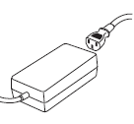
Closing the Jupiter for portability | Use both hands to gently push the LCD screen down and toward the main body of the frame, and fold it down to collapse the stand. | 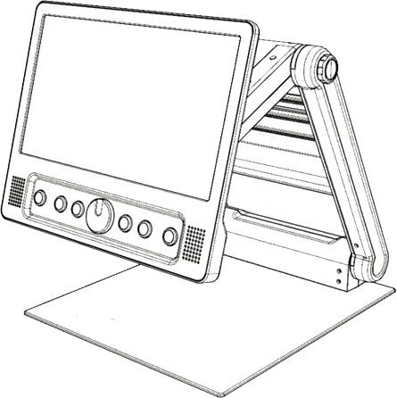
Put the Jupiter into protective pouch | Place into carrying-case for storage  (Optional) bag Fits into the Transition Tote Backpack from APH | 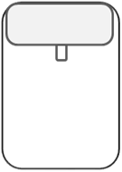

Reading, Distance-view and Self-view
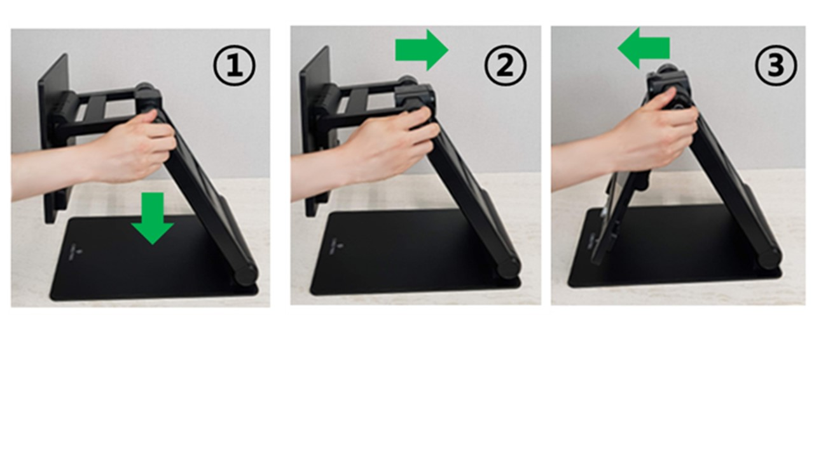
Skill | Action/Gesture | Mastery Level | Date
Rotating Camera | Use the Camera location adjustment wheel to position the camera into three viewing modes.
Reading | The camera is positioned down in reading mode.
Distance View | To view something at a distance, such as a whiteboard, rotate the camera so that it is parallel with the stand and open the conversion lens for optimal distance magnification.  Point the camera at what you want to view. Turn the Zoom wheel to the right to Zoom In or to the left to Zoom Out.
Self-view | To view yourself, rotate the camera until it faces you and you can see yourself on Jupiter’s screen or on an attached display device.  When the camera is facing you, the image is flipped so it is like you are looking in a mirror.

